
Department of Computing Technology
Faculty of Engineering and Technology
SRM Institute of Science and Technology
SRM Nagar, Kattankulathur - 603 203, Chengalpattu Dt.

REPORT:

Department : Computing Technology
Course Code/Name : 21CSC101T-Object Oriented Design and Programming.
Faculty : Dr P SelvaMeena
Academic Year : 2025 – 2026
Year / Semester : I / II
Slot / Room No : G/806

Proposed Title of the Project: Online Quiz App
Rationale for Selecting the Topic:
The Online Quiz Application was chosen as the project topic because it is a simple yet effective system to demonstrate key Object-Oriented Programming (OOP) concepts such as classes, objects, encapsulation, and modular design.
This application has real-world relevance, as online quizzes are widely used in education, recruitment, and skill assessment platforms. It provides a practical understanding of how user interaction, data handling, and result evaluation work together in an application.
Additionally, the project is suitable for beginners as it allows implementation of core programming logic without excessive complexity, while still offering opportunities for future enhancements like timers, score storage, and graphical interfaces.

Synopsis of the Report and Mapping with the SGDs (50–100 words):

The Online Quiz Application is a console-based system developed in C++ that enables users to attempt multiple-choice questions and receive instant results. It demonstrates key Object-Oriented Programming concepts such as classes, encapsulation, and modular design. The application ensures interactive learning and efficient evaluation.
This project aligns with United Nations Sustainable Development Goals (SDGs), particularly SDG 4: Quality Education, by promoting accessible digital learning tools and enhancing knowledge assessment methods.

Expected Learning Outcomes:
1. Understand and apply core Object-Oriented Programming (OOP) concepts such as classes, objects, encapsulation, and modular design.
2. Develop the ability to design and implement a real-world application using C++ programming.
3. Gain experience in creating user-interactive programs with proper input and output handling.

Group Members:
S. No | Register Number | Name | Dept.  /Section | Role
1 | RA2511003010793 | ARCHANA DK | CTECH  K1 | Ppt and Scripting
2 | RA2511003010794 | JAYANT KUMAR | CTECH  K1 | Editor
3 | RA2511003010795 | PIYUSH KUMAR GUPTA | CTECH  K1 | Reviewing
4 | RA2511003010796 | SAYANTAN BISWAS | CTECH  K1 | Rehearsal management
5 | RA2511003010797 | TOSHITAA ASHISH | CTECH  K1 | Planning and Scripting
6 | RA2511003012417 | OM RAJPUT | CTECH  K1 | Slide planning and report
7 | RA2511003012418 | ADVIKA SINGH | CTECH  K1 | Design, visuals and report
8

Faculty Approval: [ ] Approved [ ] Resubmit with modifications

Remarks:

Signature of Faculty
1. Introduction
The Online Quiz Application is a console-based system developed using C++ that allows users to attempt multiple-choice questions and receive a score based on their performance. This project demonstrates the use of Object-Oriented Programming (OOP) concepts such as classes, objects, encapsulation, and modular design.
2. Objective
- To design a quiz system using OOP principles
- To allow users to answer questions interactively
- To calculate and display results
3. System Design
The system is divided into three main classes:
- Question
- Quiz
- User
These classes interact with each other to perform the quiz operations.
4. UML Diagrams
4.1 Class Diagram:
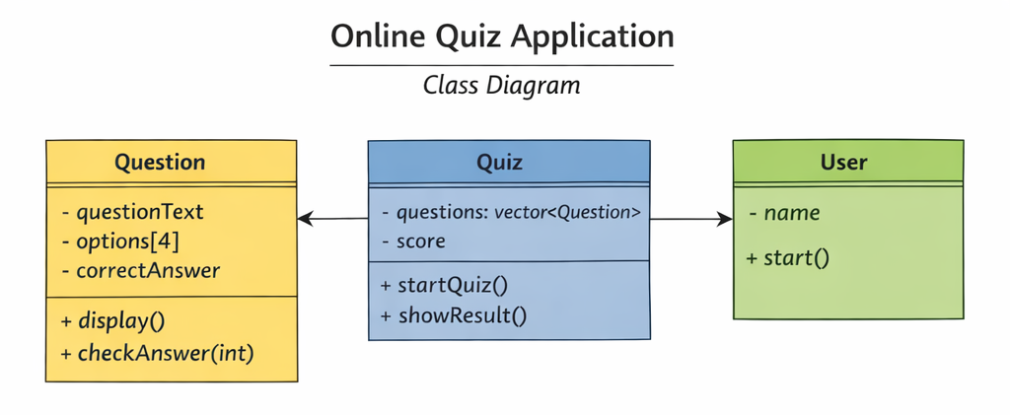

Explanation:
- Question class stores question text, options, and correct answer
- Quiz class manages list of questions and score
- User class starts the quiz

4.2 Use Case Diagram:
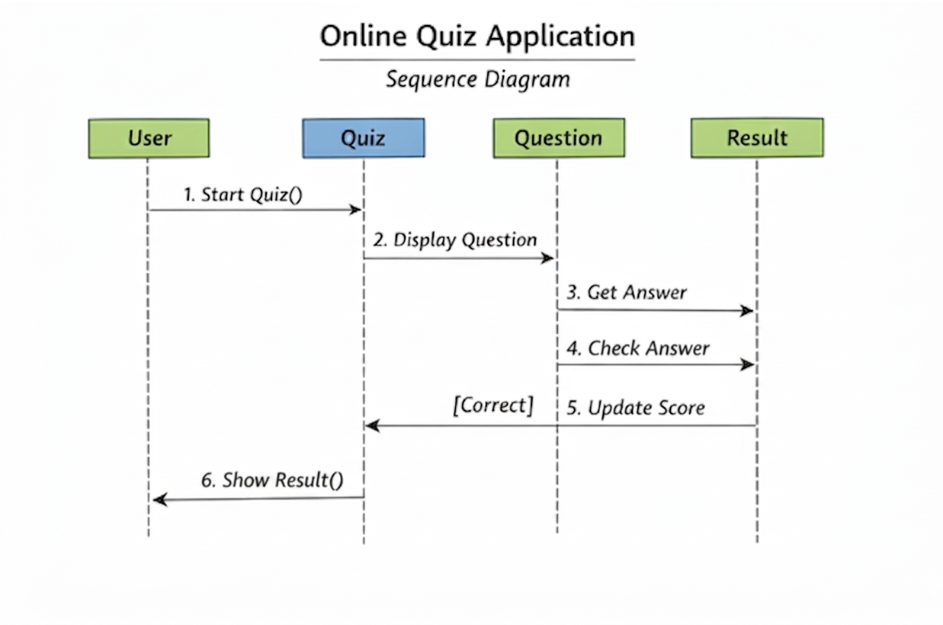

Explanation:
- Actor: User
- Actions: Start Quiz, Answer Questions, View Results

4.3 Sequence Diagram:
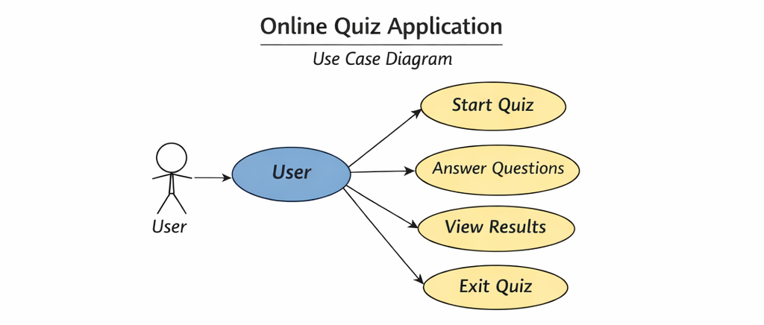

Explanation:
- Shows interaction between User, Quiz, Question, and Result

5. Implementation (C++ Code):
#include <iostream>
using namespace std;
class Question { // Question Class
private:
string questionText;
string options[4];
int correctAnswer;
public:
Question() {} // Default constructor
Question(string q, string opt[], int ans) {
questionText = q;

for (int i = 0; i < 4; i++) {
options[i] = opt[i];
}
correctAnswer = ans;
}
void display() {
cout << "\n" << questionText << endl;
for (int i = 0; i < 4; i++) {
cout << i + 1 << ". " << options[i] << endl;
}
}
bool checkAnswer(int userAnswer) {
return userAnswer == correctAnswer;
}
};
class Quiz { // Quiz Class
private:
Question questions[3];
int score;
int count;
public:
Quiz() {
score = 0;
count = 0;

}
void addQuestion(Question q) {
if (count < 3) {
questions[count] = q;
count++;
}
}
void startQuiz() {
int answer;
for (int i = 0; i < count; i++) {
questions[i].display();
cout << "Enter your answer (1-4): ";
cin >> answer;
if (questions[i].checkAnswer(answer)) {
cout << "Correct!\n";
score++;
} else {
cout << "Wrong!\n";
}
}
}
void showResult() {
cout << "\nYour Score: " << score << "/" << count << endl;
}

};
class User { // User Class
private:
string name;
public:
void start() {
cout << "Enter your name: ";
cin >> name;
Quiz quiz;
string opt1[] = {"Paris", "London", "Berlin", "Rome"};
quiz.addQuestion(Question("What is the capital of France?", opt1, 1));
string opt2[] = {"3", "4", "5", "6"};
quiz addQuestion(Question("2 + 2 = ?", opt2, 2));
string opt3[] = {"Earth", "Mars", "Jupiter", "Saturn"};
quiz.addQuestion(Question("Largest planet?", opt3, 3));
quiz.startQuiz();
quiz.showResult();
}
};
int main() { // Main Function
User user;
user.start();
return 0;
}

6. Output
- User enters name
- Questions are displayed
- User selects answers
- Final score is shown

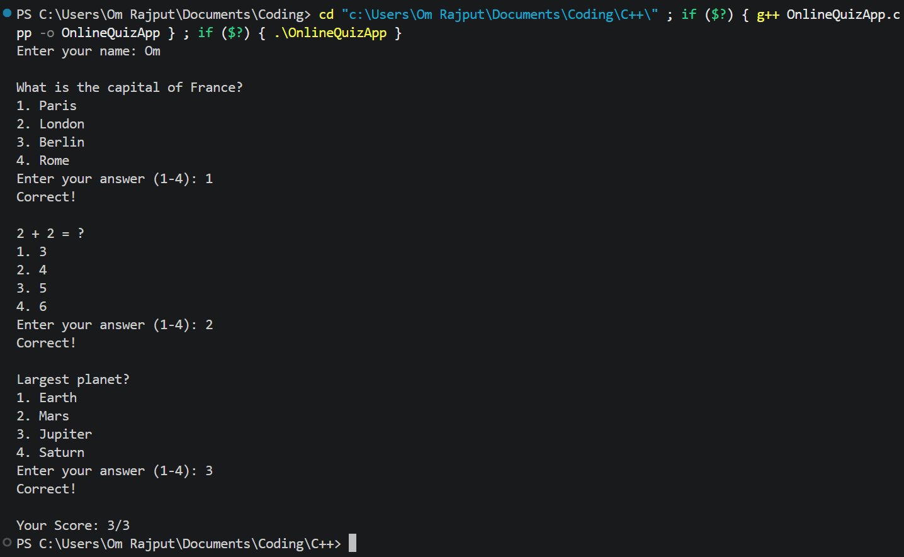

7. Conclusion
The Online Quiz Application successfully demonstrates the use of OOP concepts in C++. It provides a simple and interactive way to conduct quizzes and evaluate user performance.

8. Future Enhancements
- Add timer for each question
- Store results using file handling
- Add difficulty levels
- GUI-based version

THANK YOU!

